High Level System Design

## How to approach HLD

* Requirements gathering
  + Functional – What operations systems will perform.
  + Non-Functional – How system will perform like
    - Scalable
    - Highly available
    - Consistent [Most recent write data is returned]
    - High Performant [High throughput and low latency]
* Capacity Estimation
* Decide Database between SQL or NoSQL based on following parameters-
  + Does system have complex queries?
  + Does system need transaction support?
  + Does system require strong Consistency or High availability?
  + Size of data that needs to be stored?
* Design database tables schema.
* What endpoints will be exposed to end users and design their structure.
* Design HLD flow of system.

## Easy Questions

### Design URL Shortener like TinyURL

1. Requirements
   1. Functional
      1. Create short URL of long URL.
      2. Get Long URL from short URL.
      3. What will be the length of short URL.
   2. Non-Functional
      1. How many active users will be at a time?
      2. Do we need to scale our system?
      3. Low Latency?
      4. High Availability?
2. Capacity estimation

* Assumptions:
  + 1000 URLs generated per second.

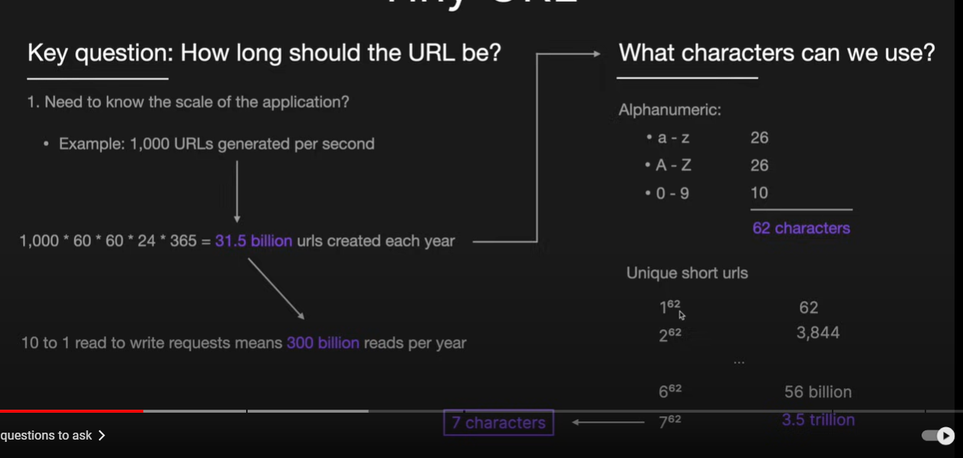

1. Database and table schema

|  |  |
| --- | --- |
| Long_URL | string |
| Short_URL | string |
| Created_at | timestamp |

1. API design

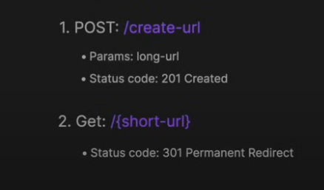

1. High level design

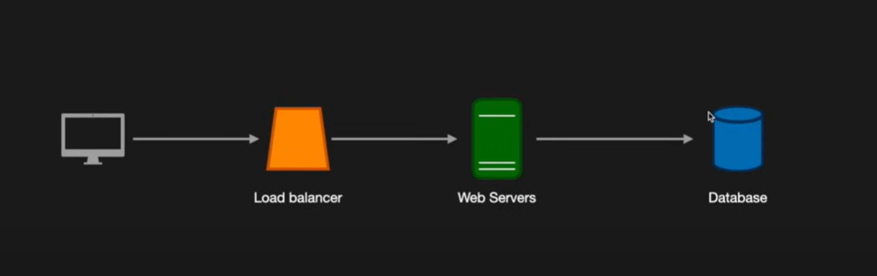

Scalable system

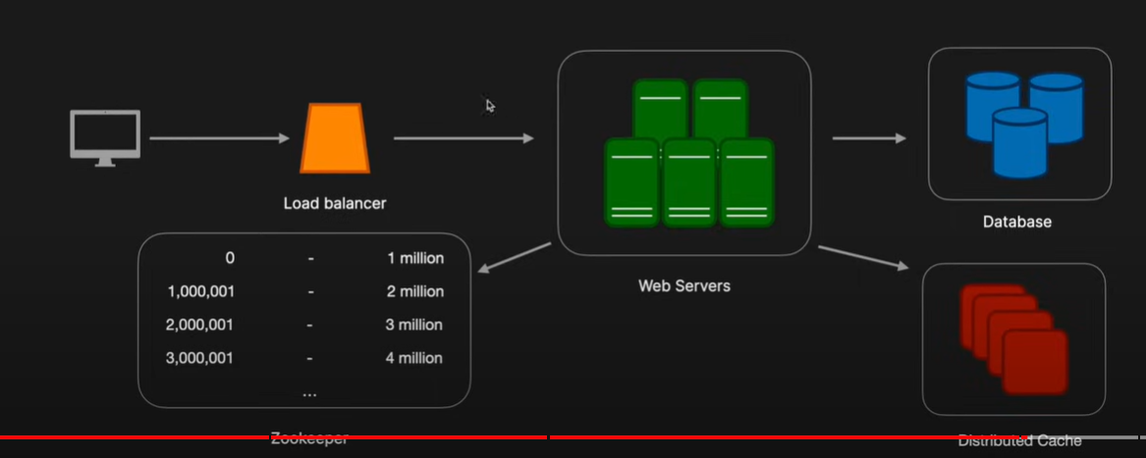

### 2.2 Design Text storage service like Pastebin

1. Requirements
   1. Functional
      1. User should be able to paste text and share that with other using URL
      2. Paste + size max 10KB
      3. Expiry of paste data
      4. Custom URL path
      5. User login
   2. Non-Functional
      1. Durability
      2. Low Latency
      3. High Availability
2. Capacity estimation

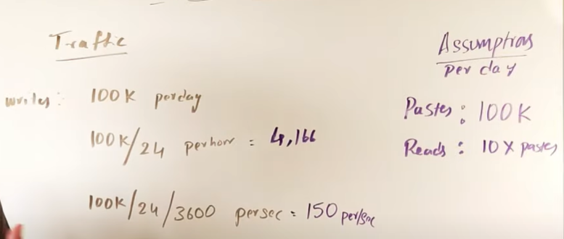

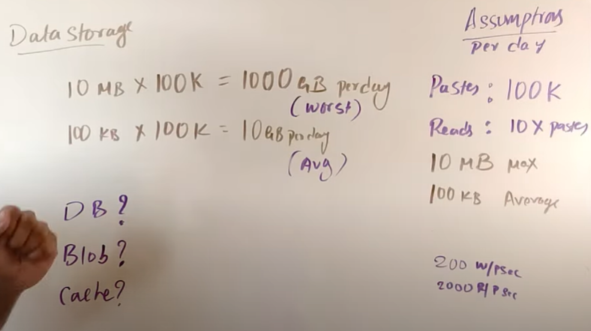

1. Database schema

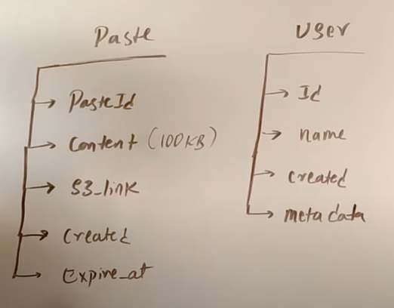

1. High level diagram

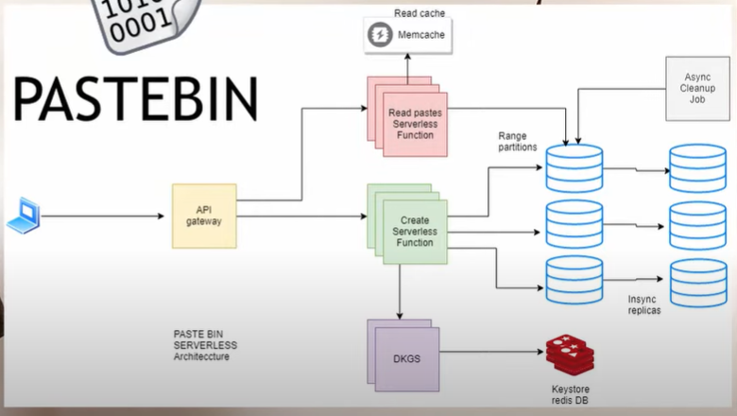

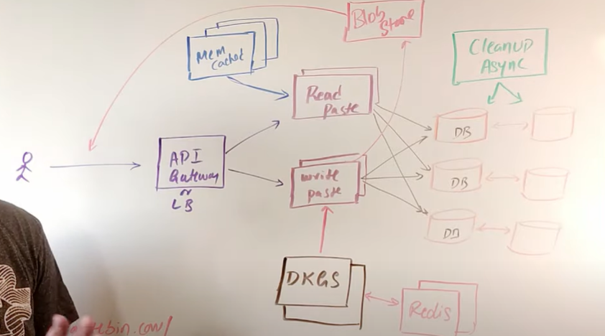

### 2.3 Design leaderboard

### 2.4 Design Content delivery network

### 2.5 Design Parking garage

* Requirements
  + Functional Requirements
    - Reserve a parking spot in garage.
    - Get receipt of payment
    - The Type of vehicle to identify the spot for that.
    - Flat Rate based on time but different rates depending on parking type.
  + Non-functional
    - Scalable
    - Strong consistent so that no two customer books same spot
* Database schema

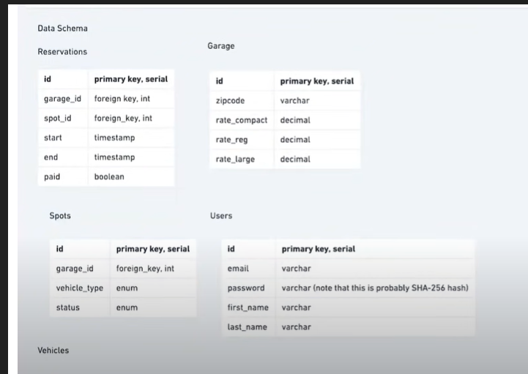

* API end points

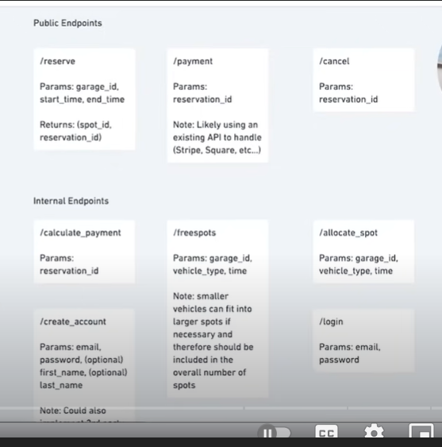

* High level flow

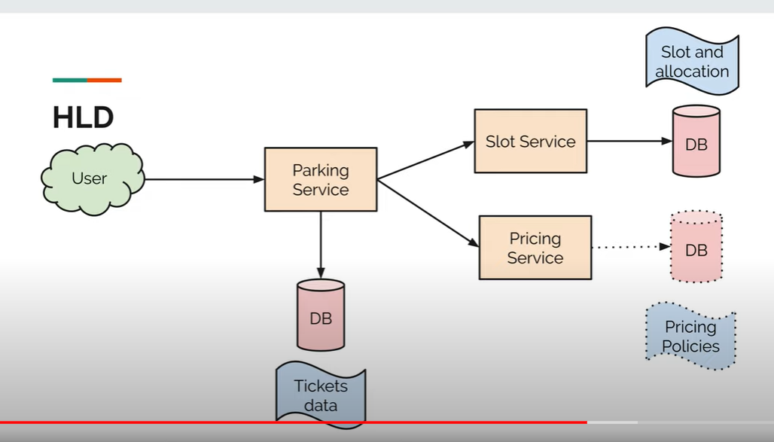

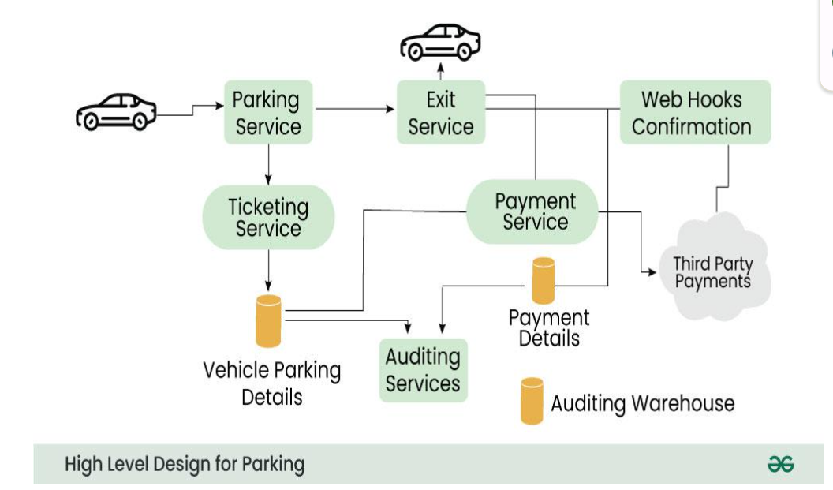

### 2.6 Design Vending machine

* Requirements
  + Functional Requirements
    - Select an item.
    - Dispense item.
    - Accept cash payment and dispense change.
    - Send notification to owner in case of out of stock.
  + Non-functional
    - It’s a machine that will be used by one person at a time, so no scaling is required.
* The flow of vending machines

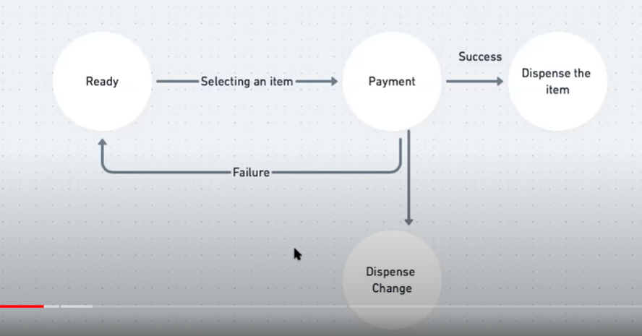

* Important components of system

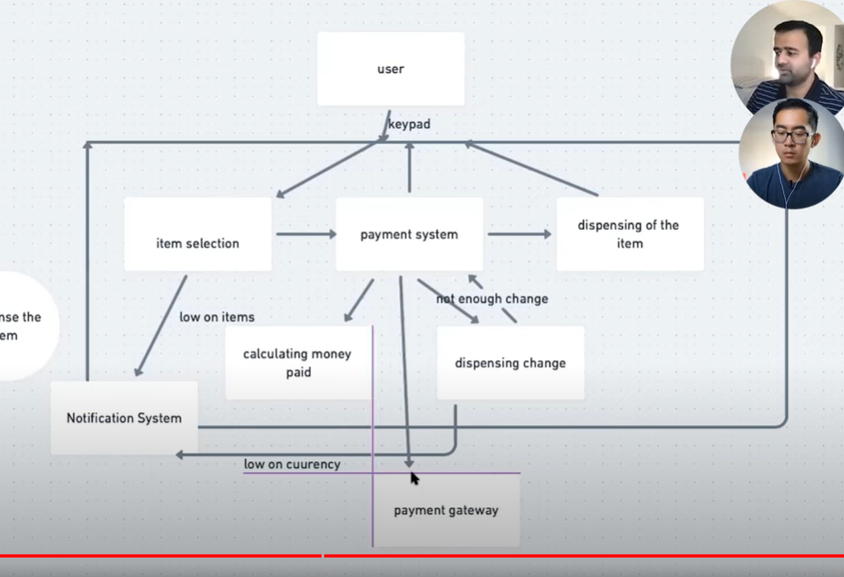

### 2.7 Design Distributed Key value store [Database]

* It is similar to distributed Cache.

### 2.8 Design distributed Cache

* Requirements
  + Functional
    - Put(key, value)
    - Get(key)
  + Non Functional
    - High scalable (scales easily with increasing number of users)
    - High available (survives hardware/network failure)
    - High performant (Low latency and high throughput)
* Implement LRU using doubly linked list for getting and storing values in memory.

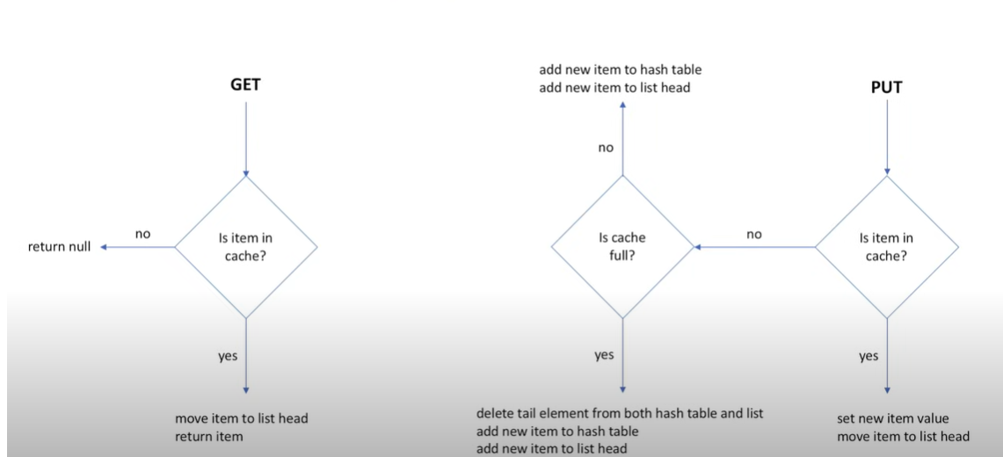

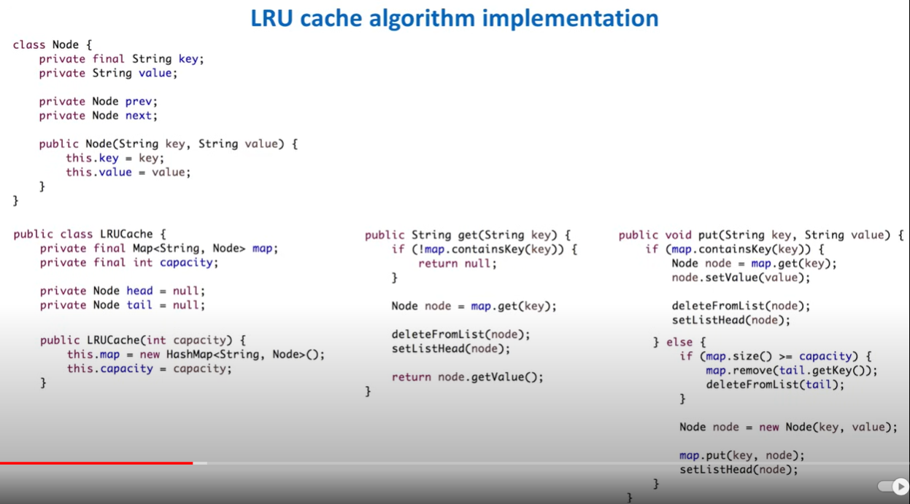

* Stepping into distributed system to server multiple users at same time.
  + Shard the cache based on some key range

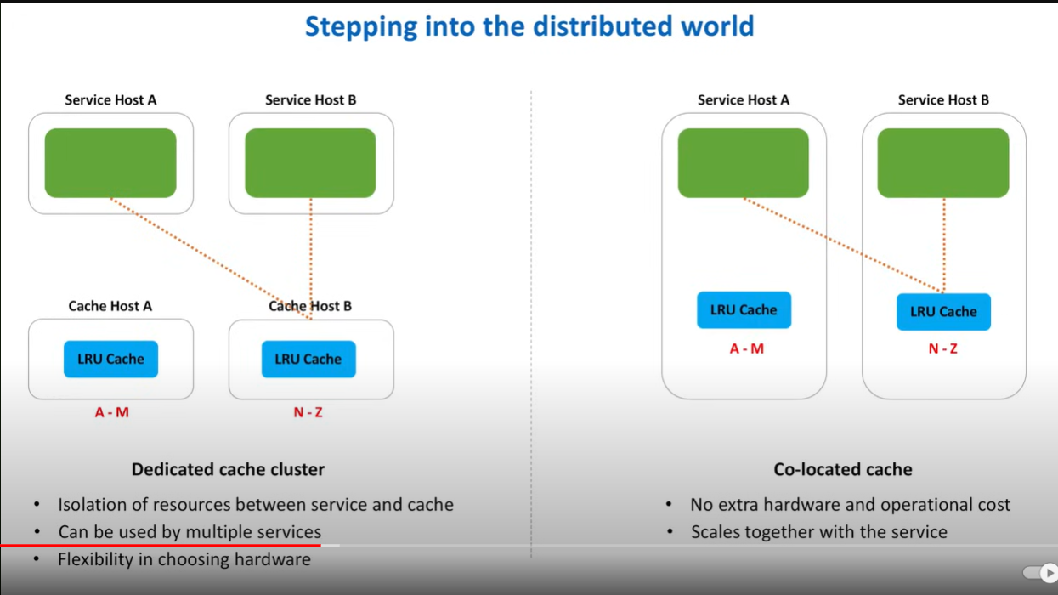

* Choosing which shard to pick

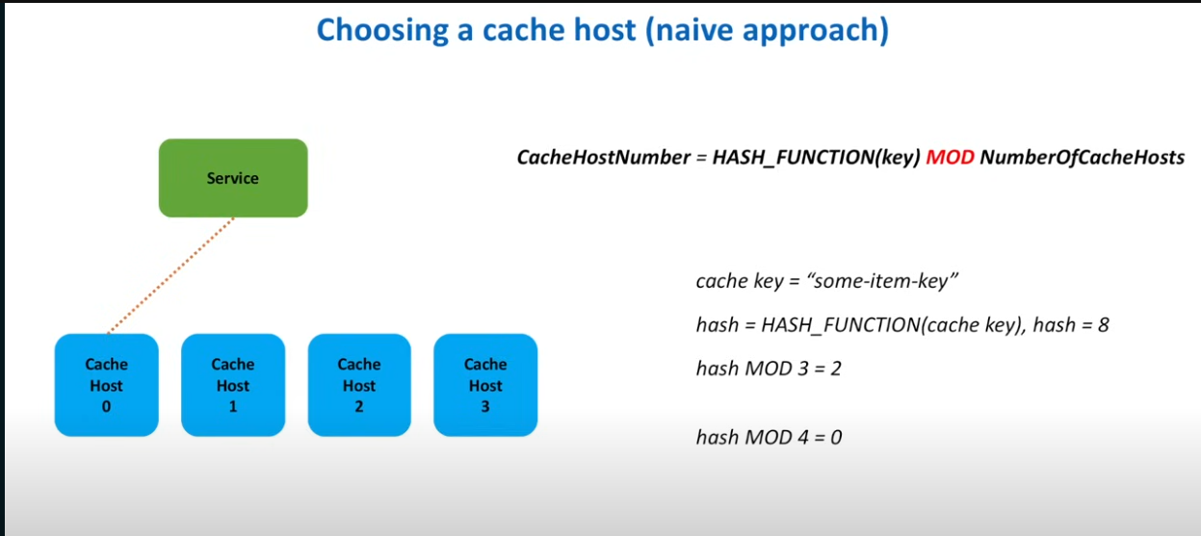

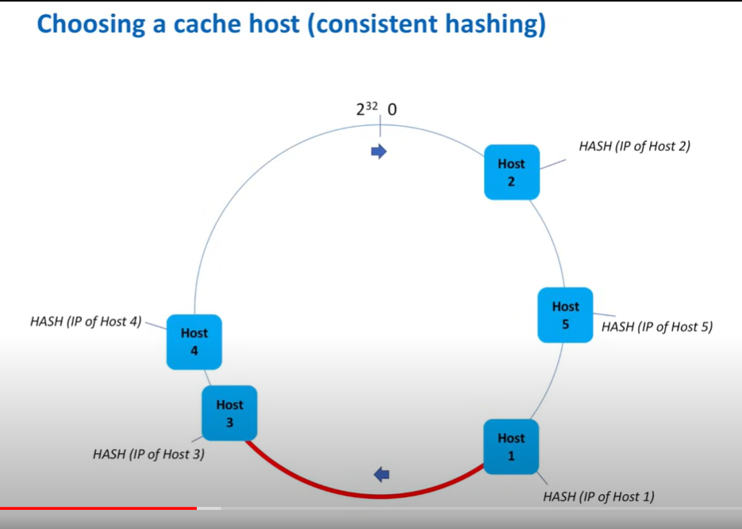

* Cache client that will choose the shard using consistent hashing

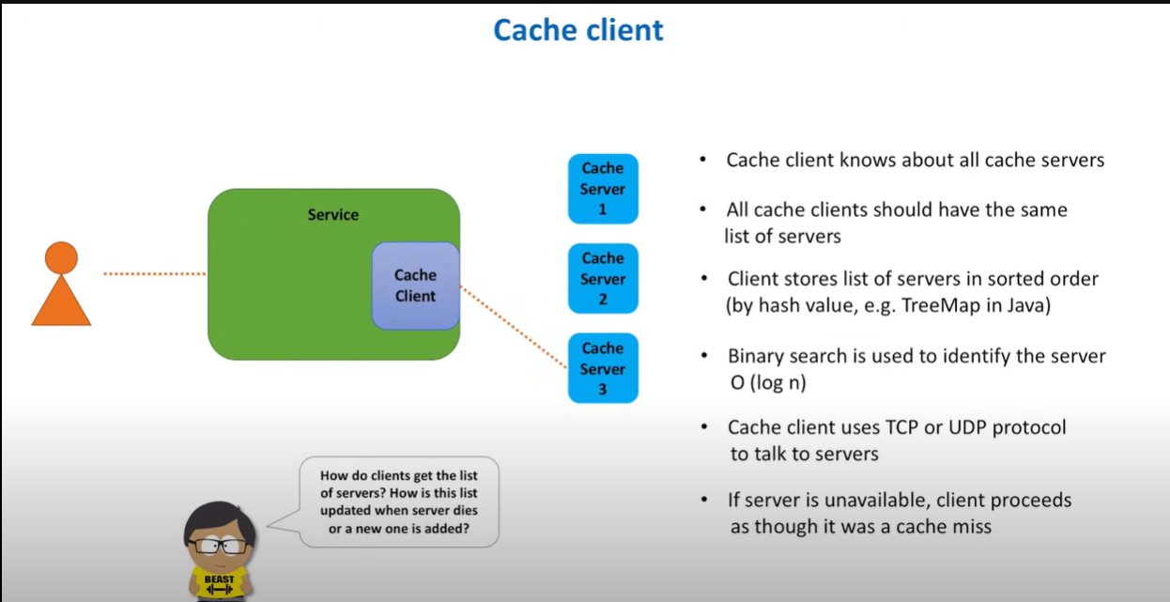

* Maintaining list of all cache servers

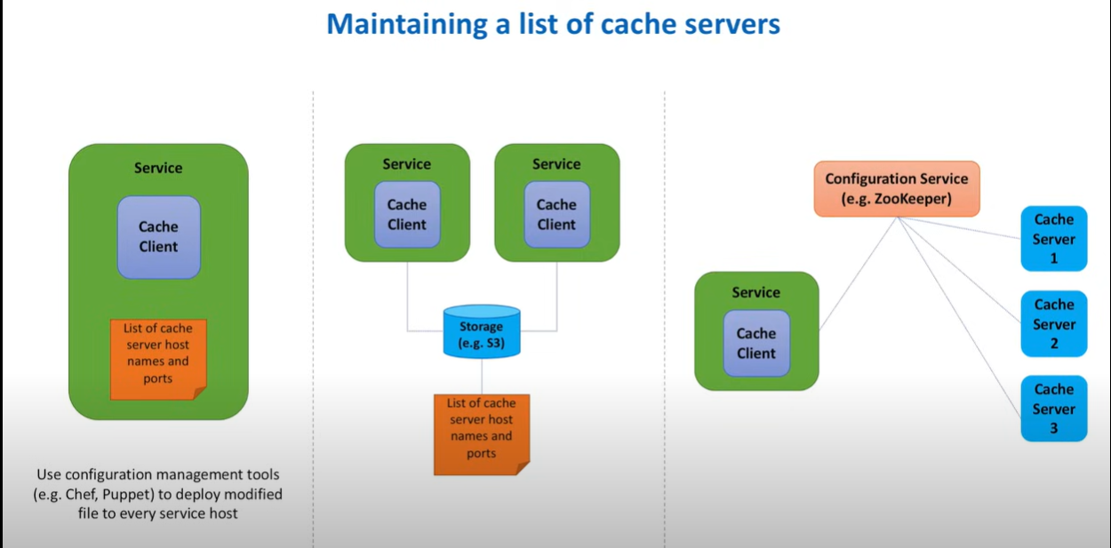

* Achieve high availability using Replication.
  + Note: If replication is asynchronous then the system will not become strong consistent.

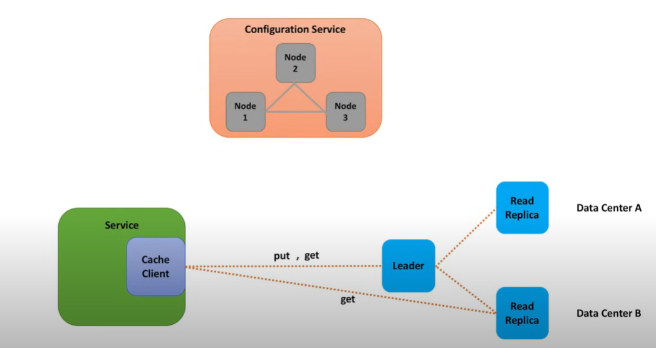

* Role and responsibilities of configuration service i.e zookeeper
  + Maintain list of active cache servers.
  + Maintain list of each master slave replication groups
    - How many replica nodes.
    - Who is leader.
  + Elect new leader in case master node fails.
* Some other important points
  + Consistency
  + Data expiration
  + Local and remote cache (local cache at cache client)
  + Security
  + Monitor and logging
  + Cache client
  + Consistent hashing
* High level diagram

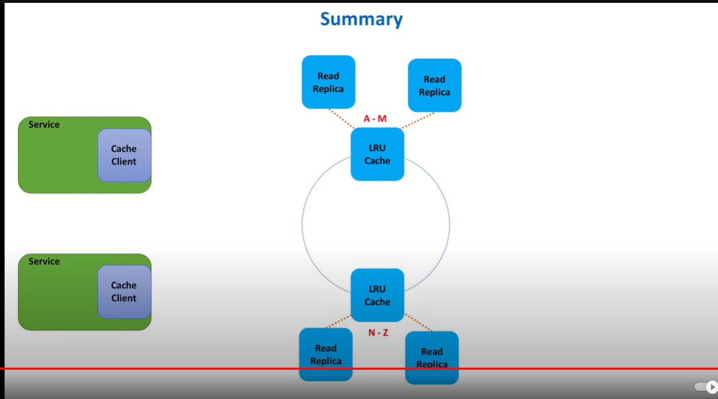

### 2.9 Design Distributed Job Scheduler

* Requirements
  + Functional:
    - Create/delete a new job with its schedule.
    - Query all jobs owned by the user.
    - Query the status of a job (running, failed, finished, etc)
    - Query the execution history of a job.
    - Retry support for failed tasks.
    - On-time execution (when a job is scheduled to run at 1 PM, it should be triggered around 1 PM)
  + Non-Functional:
    - Scalable
    - High availability
* Database schema

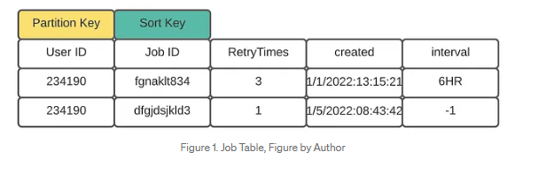

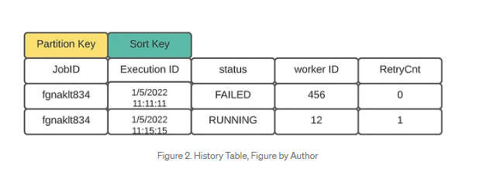

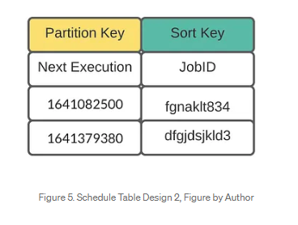

* API design

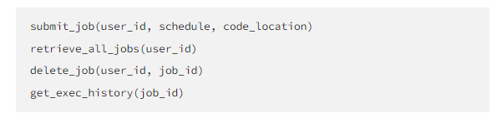

* High level diagram

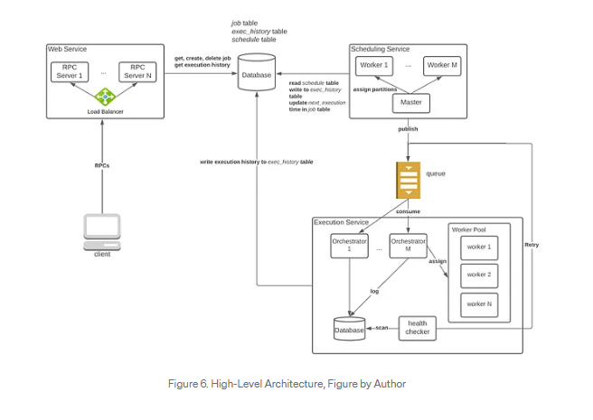

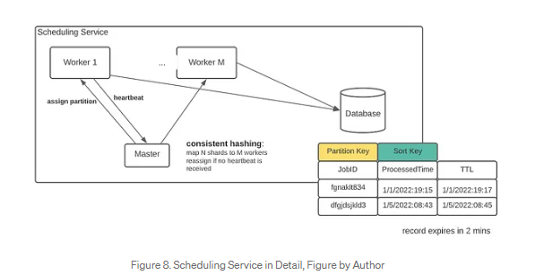

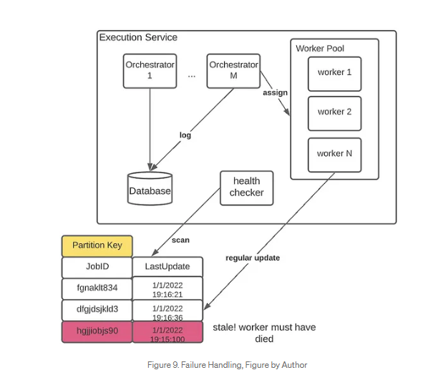

### 2.10 Design Authentication system

* Requirements
  + Functional:
    - User can authenticate.
    - Other apps can authorize the user.
    - User can login
  + Non-Functional
    - Scalable
    - High Availability
* Some important points:
  + HTTPS is stateless protocol means it don’t remember any information about the request like user info etc.
  + To make HTTP stateful by adding some information in header of HTTPS request.
  + Cookies: Browser can store the data in cookies. And this data can be sent in HTTP request in header.
  + Local storage: Browser can store the session id in local storage. It is like database of Front end.
* This can be implemented using session id and JWT token.

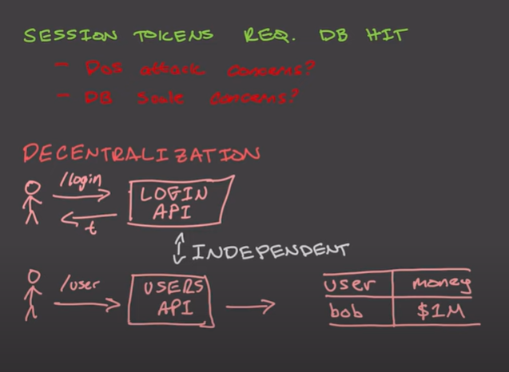

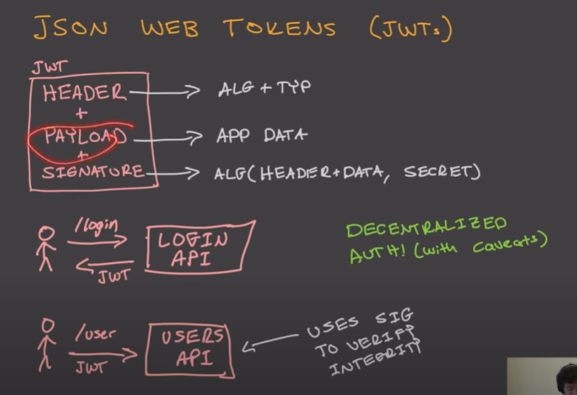

* Session id does not contain extra information about user, but JWT token itself embedded with user information.

### 2.11 Design Unified payment interface UPI system

* Requirements
  + Functional
    - User can register.
    - User can make payments to other.
    - Collect request can be send to user.
    - Notification will be sent to all involved entity.
  + Non-functional
    - Scalable
    - Strong consistent
* National payment corporation of India is the main entity.
* Each payment application is linked with one or more bank which will be called Payment Service provider (PSP)
* Flow of payment from A to B

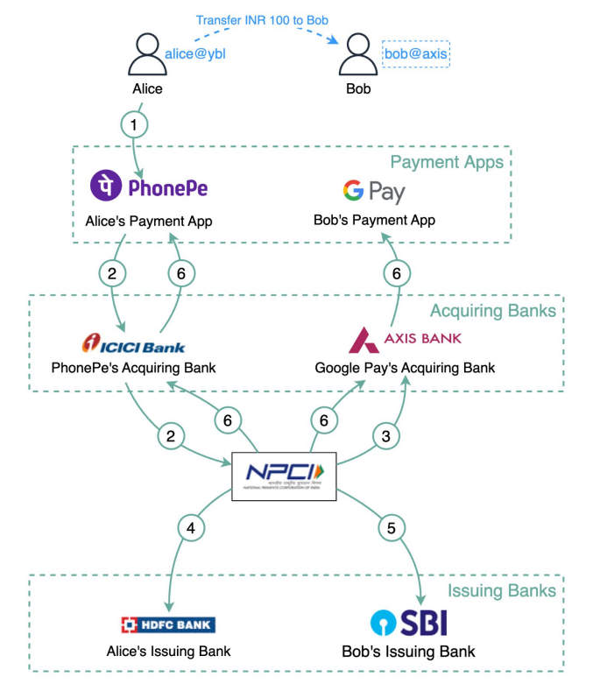

## Medium Questions

### Design Instagram

* Requirements
  + Functional:
    - User can post photos.
    - User can follow other people.
    - User can see feed of all followers.
  + Non Functional
    - Scalable
    - High availability
    - Low Latency
* Capacity estimation
  + Assume 10 million users monthly.
  + Each user can upload 2 photos per day
  + The max size of each photo is 5 MB
  + Total size per months: 10^7 * 2 * 5 MB = 10^8 MB = 100 TB
* Database schema
  + There is relation among users, photo and followers.
  + Three tables
    - Users
    - Photos
    - Followers
  + Database can be scale by adding more replicas like multi master.
* High level design

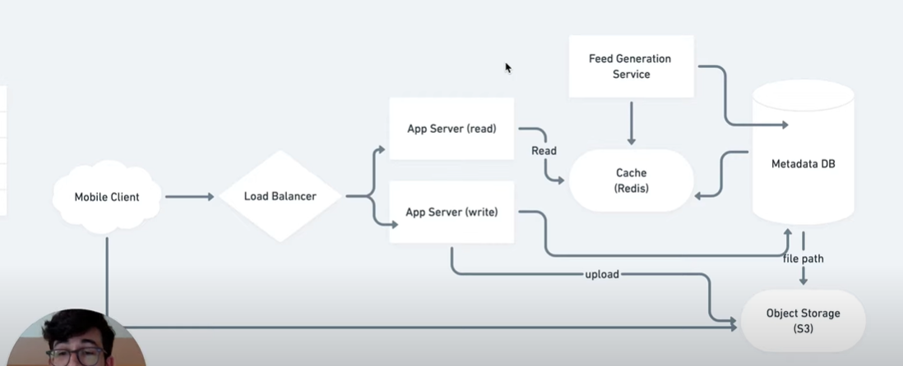

### Design Tinder

* Requirements
  + Functional
    - Store user profile.
    - Recommend matches.
    - Note matches of users.
    - Direct messaging
  + Non-Functional
    - Scalable
    - High Availability
    - Low latency
    - Eventual consistency
* Capacity estimation
* Decide where to store images: Blob or File
  + Blob is Binary large object that can be stored in database like Postgres under BYTEA column.
  + Blob type in database will provide:
    - Mutability
    - Access Control
    - Indexes
    - Transactions
  + Distributed file system will provide:
    - Cheaper
    - Fast
    - CDN as cache for faster access
* Database schema
  + SQL database for storing user profile data
  + NoSQL (DynamoDB ot Casandra) for storing user name, location and age for recommendation service.
* High level system diagram

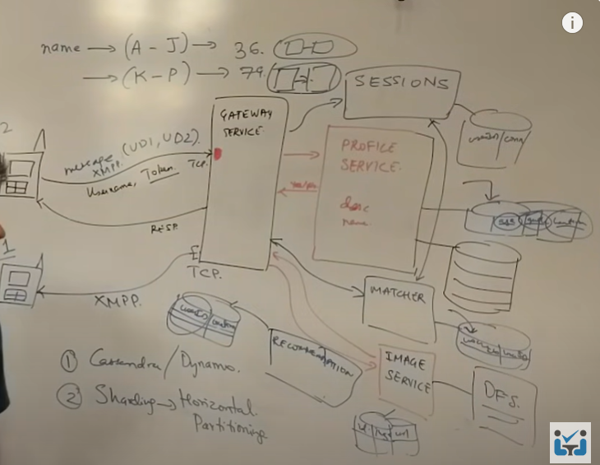

### Design Whatsapp

* Requirements
  + Functional requirements
    - Group messaging.
    - Sent, Read and delivered notifications to user.
    - Online/ last seen.
    - Image sharing
    - Chats are temporary/permanent.
  + Non functional requirements
    - Scalable
    - Highly available
    - Low latency high throughput
    - Eventual consistency
* Flow of direct message

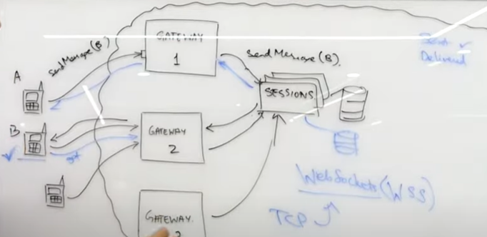

* Flow of online/last seen.
  + Last seen will be updated as per user activity.
  + Last seen will not be updated for app activities like notification sent to user about message delivered.

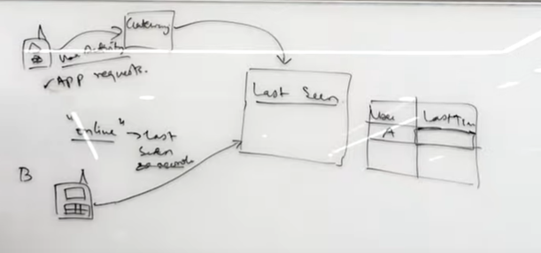

* Group messaging.
  + For serialization of digital messages, use thrift. It will help in memory optimization of API gateway,

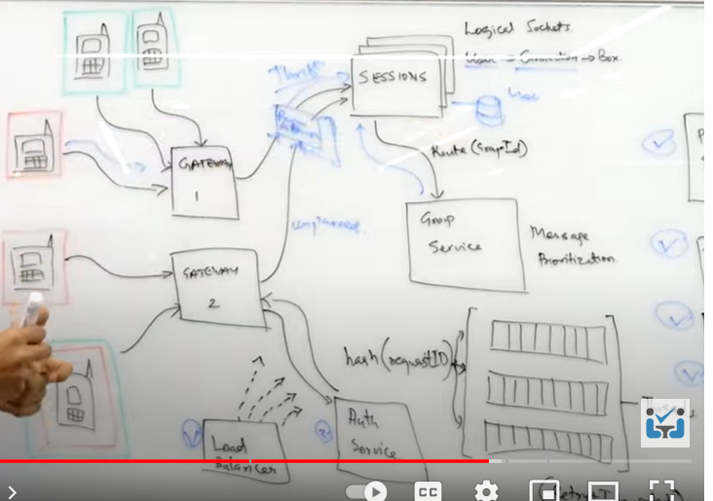

Scaling of Group service using consistent hashing.

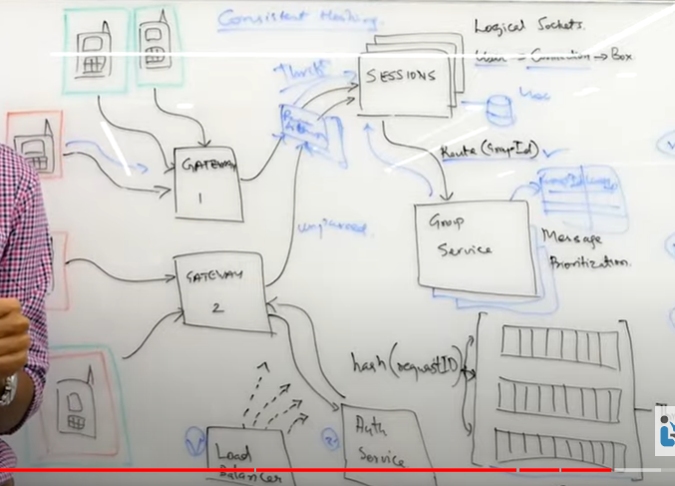

### Design Facebook

* Requirements
  + Functional requirements
    - Post (Images or videos)
    - Like, comment and share
    - Add friends.
    - See timeline/feed.
    - See a user post and profile.
    - Activity log
  + Non-Functional requirements
    - Read heavy system.
    - Low latency
    - Eventual consistency (lag is ok)
    - Access pattern
    - Scalable
    - Global app
* Types of users
  + Famous
  + Active
  + In Active

K

A

F

K

a

* + Passive
  + Live
* Add friend flow:
  + MySQL is used because data is in structured form.
  + Users table will have some mandatory parameters.

MySQL cluster

User service

Load

balancer

User Onboarding

Redis cluster

MySQL cluster

Graph service

Load balancer

Add friend.

* High level flow of Facebook

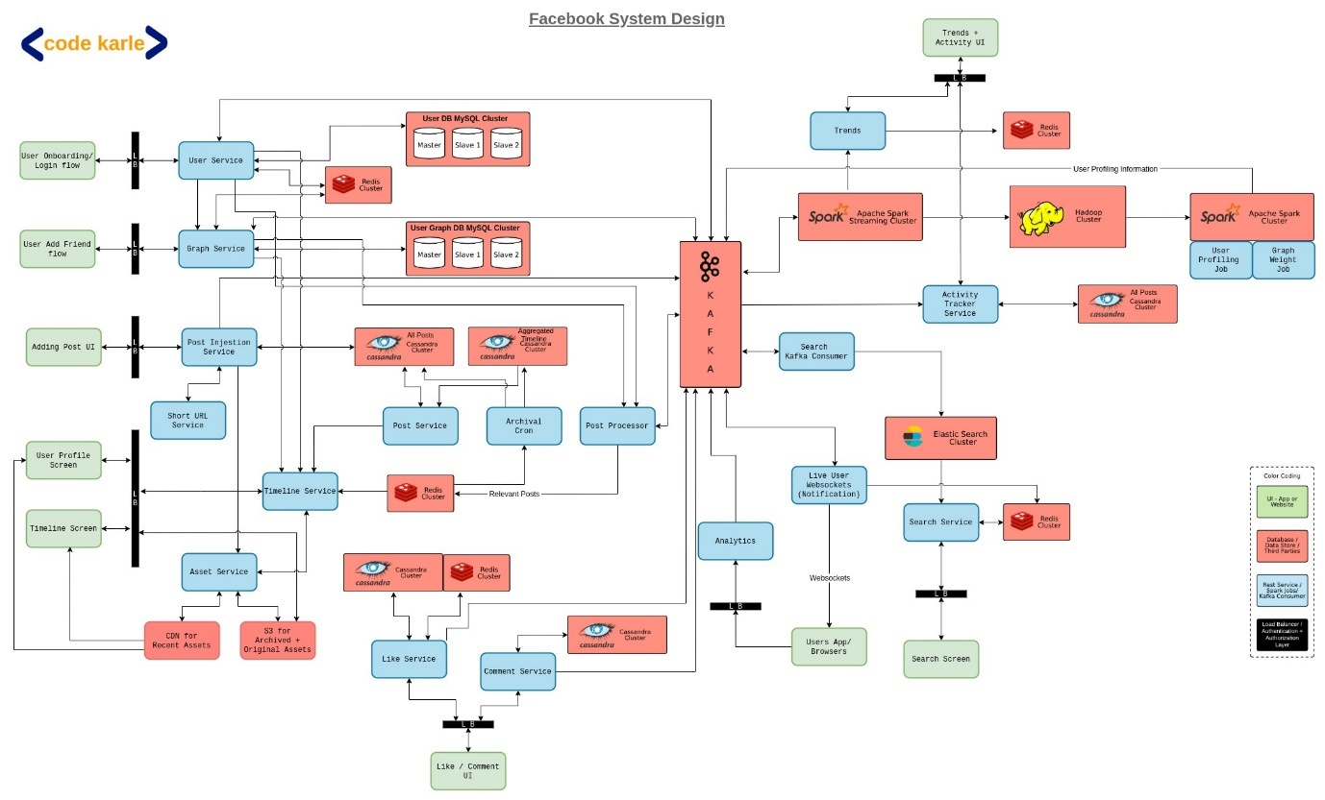

### Design Twitter

* + Requirements
    - Functional
      * User can post new tweet.
      * User can see home timeline and user timeline.
      * Follow another person.
      * Search tweet.
      * Find trending trends.
    - Non-functional
      * Read heavy system.
      * High availability
      * Eventual consistency
      * Low latency
      * Scalable
  + Type of Users
    - Famous
    - Active
    - Live
    - Passive
    - In Active
  + WebSocket will be used for persistent connection between client and server.
    - It is stateful.
    - It is persistent connection.
    - It works on TCP.
    - First HTTP connection gets established between client and server. Then client sends upgrade request for converting HTTP connection to WebSocket.
  + High level diagram of Twitter

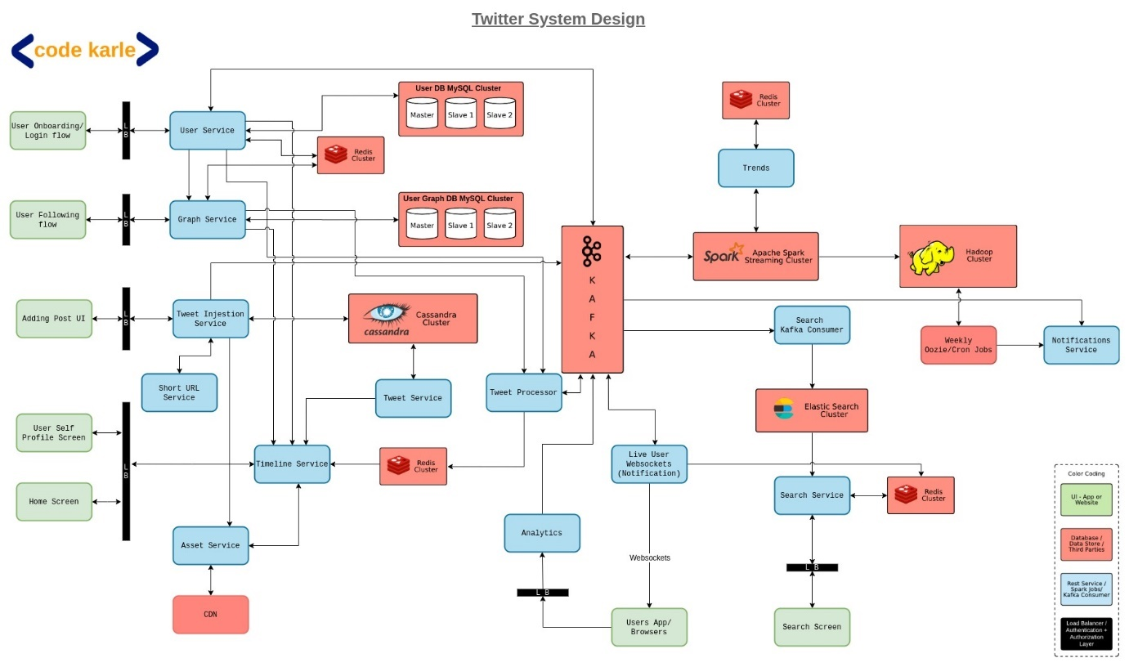

* + How to store most frequently used data in Redis like Users, their followers, their user timeline and home timeline.
* Redis will store following information.
  + Per user followers list
  + Per user their user timeline. Whenever there is a new tweet then it will get store in Redis and database both.
  + Per user their home timeline.
    - Whenever a person tweets then that tweet will gets added in user timeline in Redis. Plus added in home timeline of their followers.
    - This will not be followed for celebrity followers as they have millions of followers.
    - In case a celebrity person post a tweet then it gets added in user timeline and in database
    - Now lets say if a user wants to see his/her home timeline and he follows 2 3 celebs. Then First all data of his/her timeline will come from Redis and plus in real time system will check is this user follow and celebrity if yes then gets latest tweet from the user timeline and show them on home timeline of user.

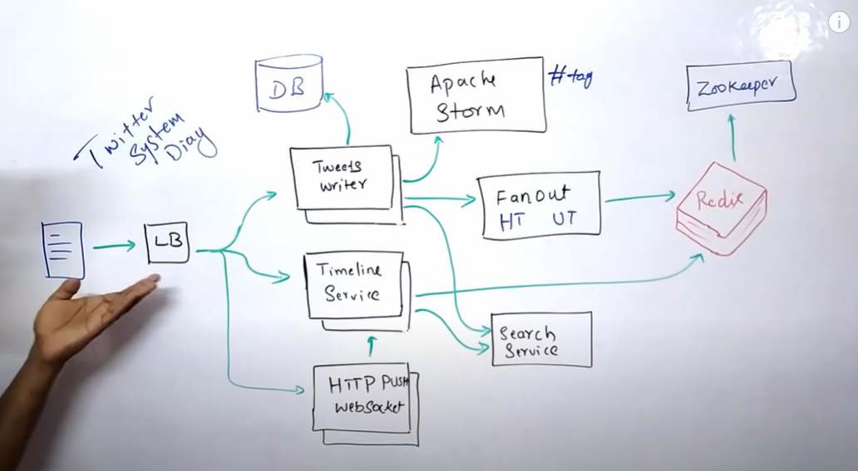

Apache storm or kafka for finding latest trends:

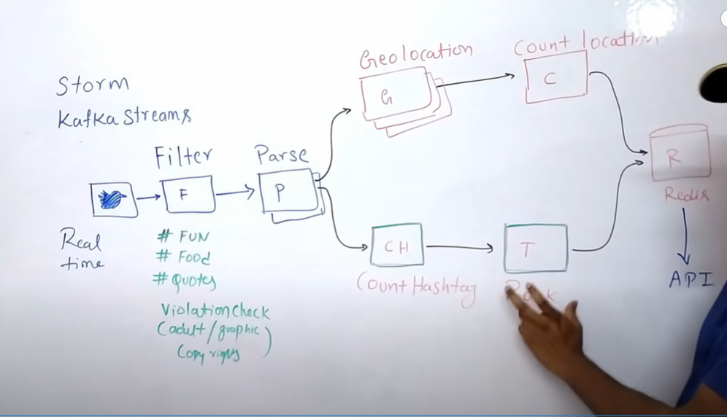

### Design Reddit

* Requirements
  + Functional
    - See feed.
    - Post image, video, or link.
    - Follow subreddit.
    - User can log in.
  + Non-Functional
    - Scalable
    - High availability
    - Eventual consistency
    - Read heavy.
    - Low latency
* Memory optimization

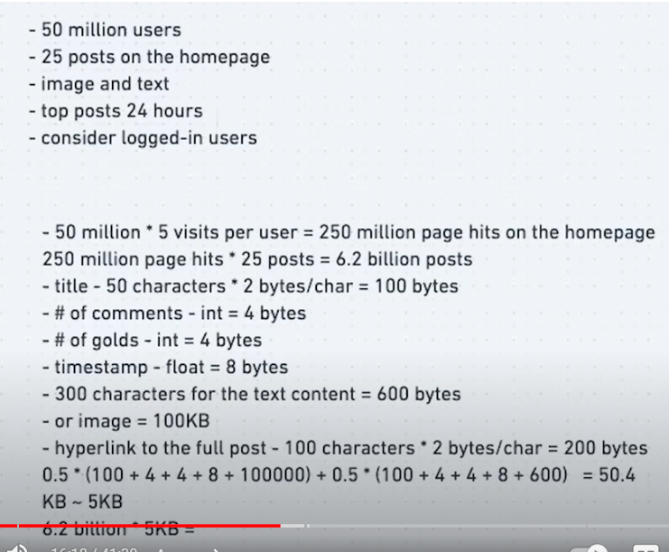

* Use Redis cache for read heavy system.
* The posts of active users will be stored in redis cluster.
* For image storage blob storage will be used.
* High level diagram

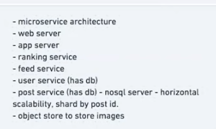

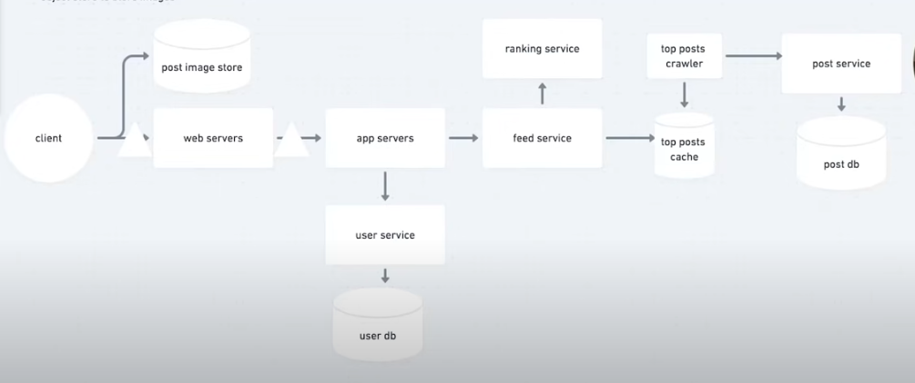

### Design Netflix

* Requirements
  + Functional
    - Stream fast video
    - Search movies/series.
    - Recommendation
    - Billing as per user
    - Transcoding of videos
  + Non-Functional
    - Highly available
    - Scalable
    - High throughput and low latency
* DB choices
  + For storing user information and billing data use SQL
  + For storing data of user watch history use NoSQL Cassandra
  + For Full text search use Elasticsearch
* Main components of Netflix
  + **Open connect**: Netflix own CDN, all video streaming is done from here.
  + **AWS**: for other user services like search, authentication, billing etc
  + **Backend**: Microservice architecture which will have critical microservices and other microservices that are not that much critical if they fail then user will not have bad experience.
  + **Client**: It can be any device phone, laptop, smart TV etc
* Some Netflix developed components:
  + **ZUUL**: Its an API gateway with lots of functionality
  + **Hystrix**: For handling distributed microservice resiliency by using circuit breaker pattern. It helps to make microservice fault tolerance.
  + **Open connect**: Netflix own CDN, all video streaming is done from here.
  + **Chaos Monkey**: For stress testing
* High level diagram

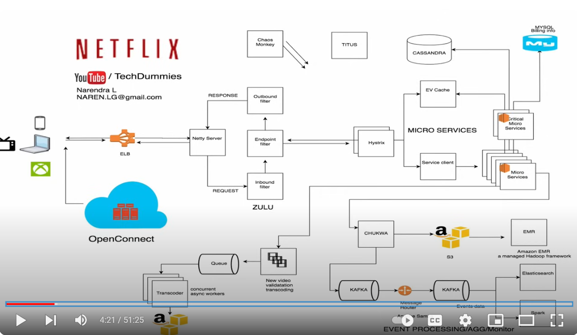

* Apache CHUKWA used to stream event data.
* Movie recommendation

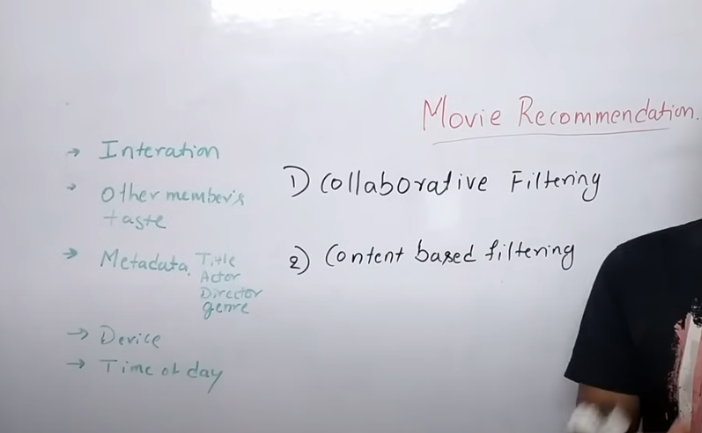

* **Collaborative filtering**: If two persons watch same movie then recommendation will suggest watched movie of first person to another person.
* **Content based filtering**: System will give suggestions based on watched content of user.

### Design Youtube

* Requirements
  + Functional
    - User can upload video.
    - User can watch video.
    - User can search.
  + Non-Functional
    - Scalable
    - High Availability
    - Low latency
    - Eventual Consistency
* Video of large size will be stored as small files.
* High level diagram

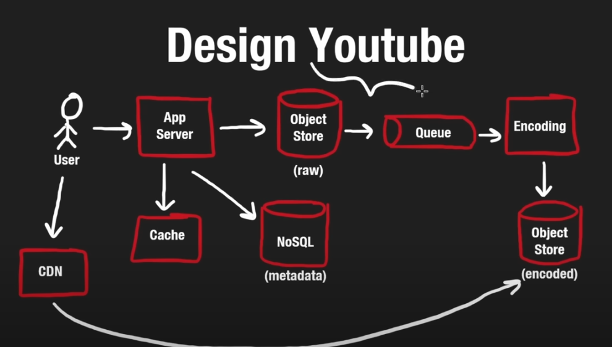

* Encoding service is same as we have explained transcoding in Netflix design that will convert the video in multiple form and resolution type.
* When a user plays a video, It does not wait to load complete video It just wait to load first small part of video. Now if user skip some part of video then an HTTP request will be sent to load that part of video.
* Youtube is not using streaming it is sending HTTP request.
* For Live streaming UDP protocol is used.

### Design Google search.

* Google search should be fast.
* System should have high throughput and low latency.
* Google search has three main components.
  + Crawling
  + Indexing
  + Query

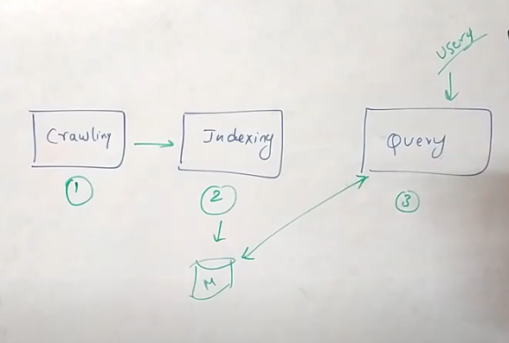

* Inverted Index will be created for fast searching in large documents.
  + Remove stop words like the, an, is from documents.
  + Remove Noise like #tags, HTTP URL.
  + Perform stemming to remove adjectives to get exact word.
  + Perform lemmatization to get meaningful English word.
* Create Inverted index with collected data.

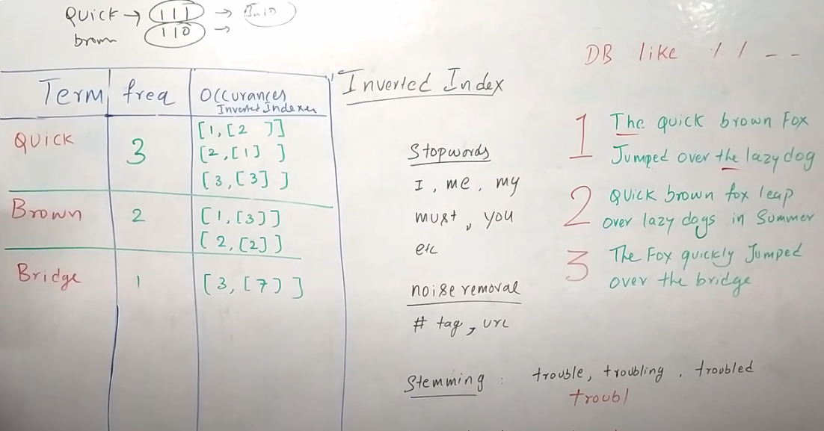

* Query search type
  + Conjunctive (AND) all words should be included in same order
  + Disjunctive (OR) any word can be found in document

### Design distributed queue system

* Requirements
  + Functional
    - Producer can sendMessage() to queue.
    - Consumer can pull message from queue.
  + Non-functional
    - Highly available (survive network/hardware failures)
    - Scalable (handle load increases, more queues and more messages)
    - Highly performant (Single digit latency for many operations)
    - Durable (data is not lost)
* High level diagram

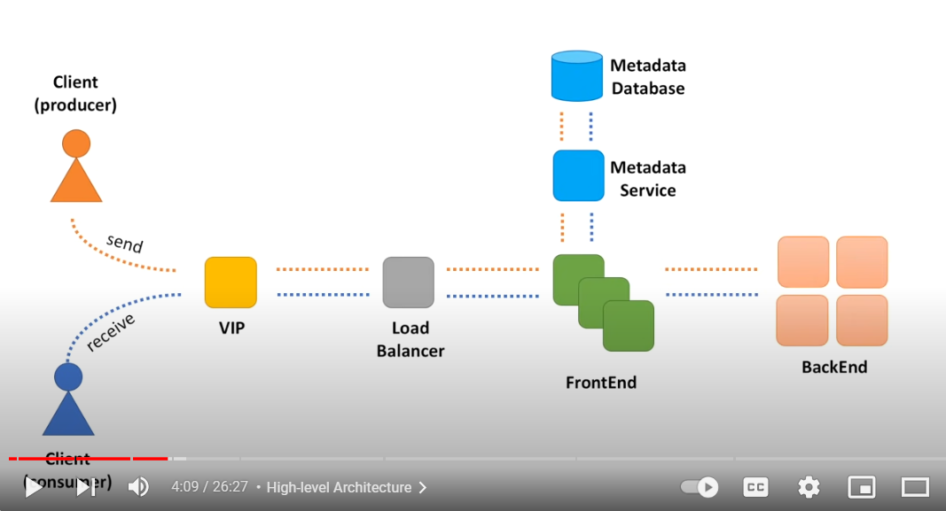

* Multi region deployment for high availability

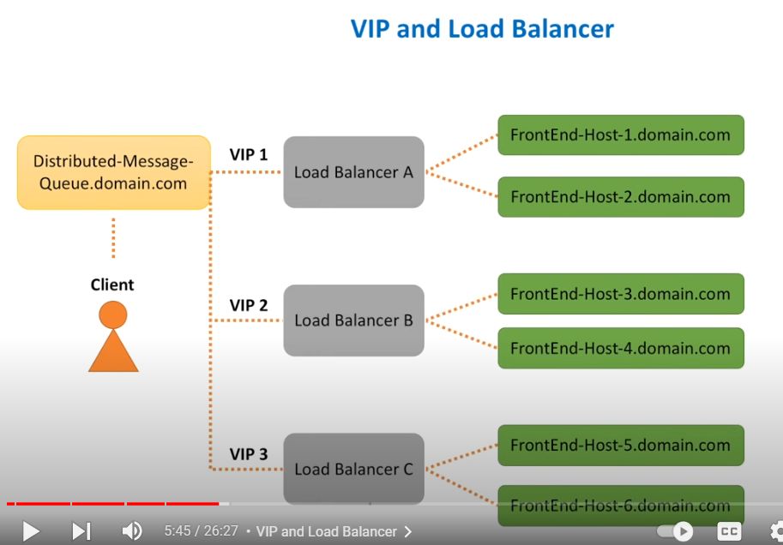

* Front end service tasks

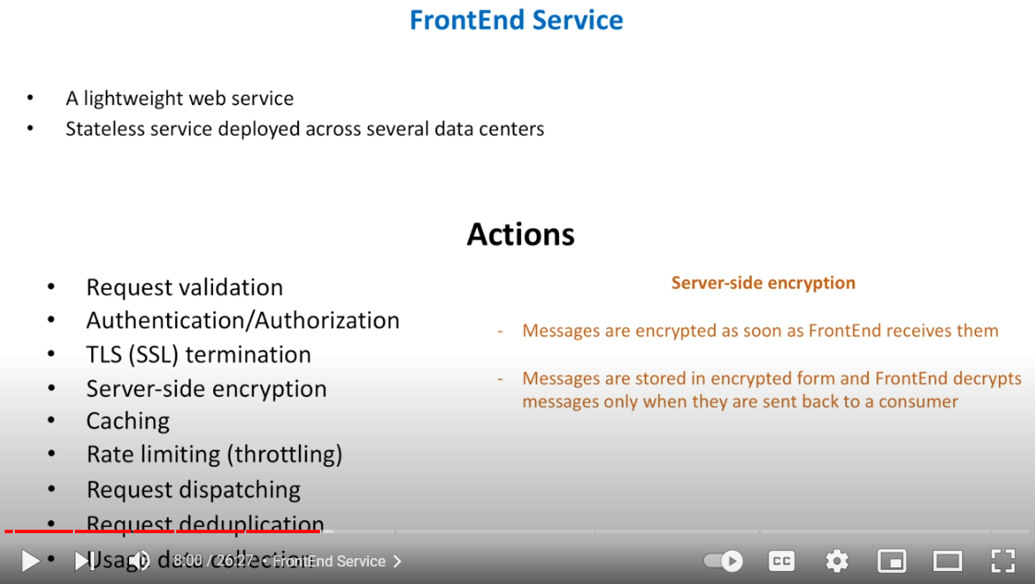

* Backend service

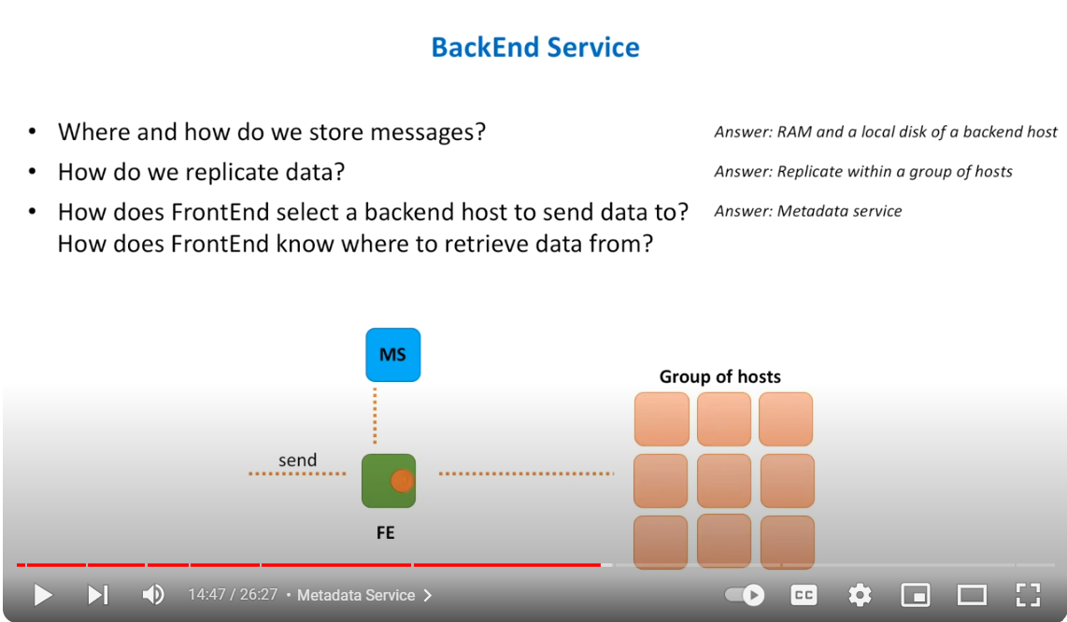

* Approaches for keeping nodes on which messages will be stored.
  + Leader follower
  + Cluster of small independent nodes

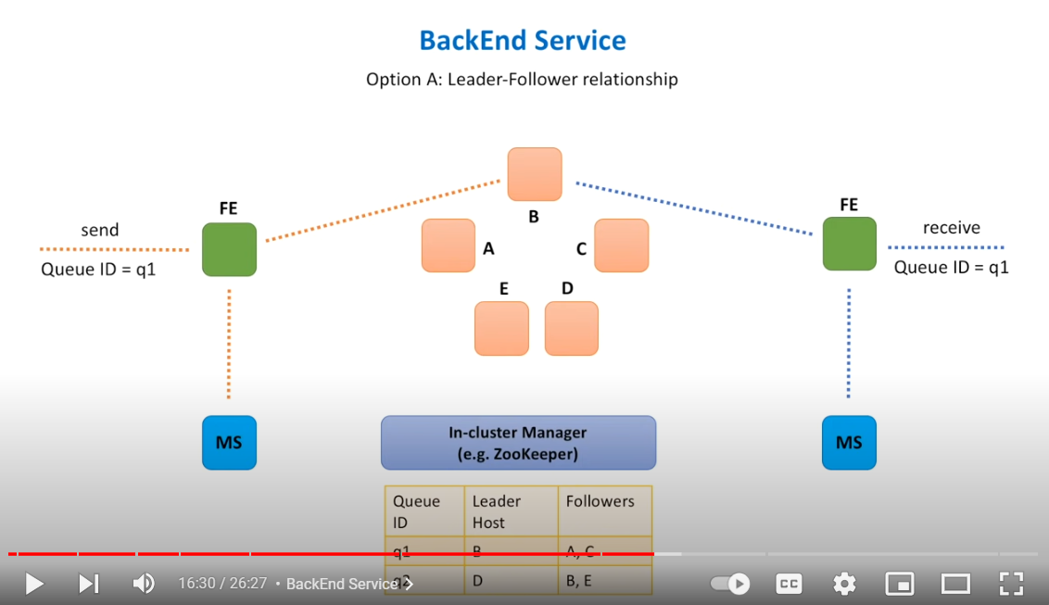

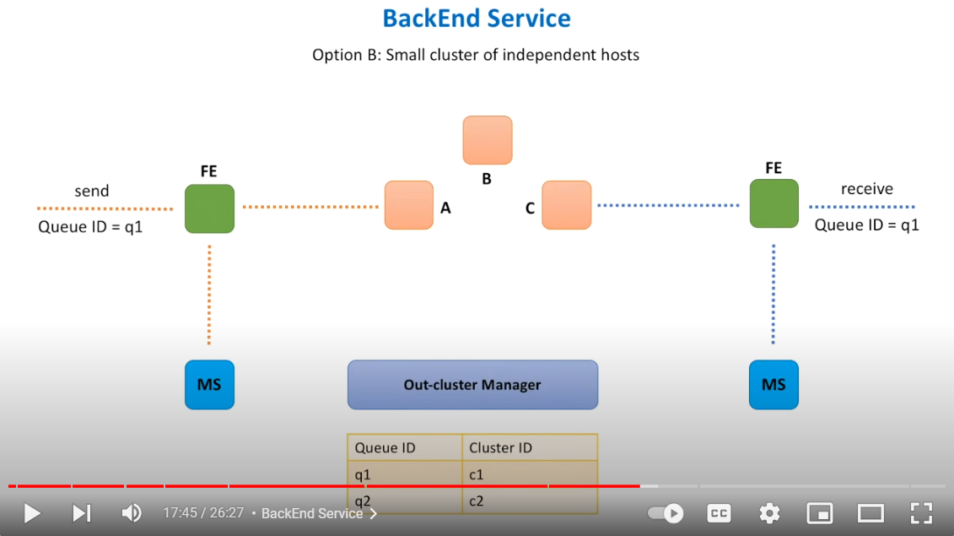

* In cluster and Out cluster Manager diff

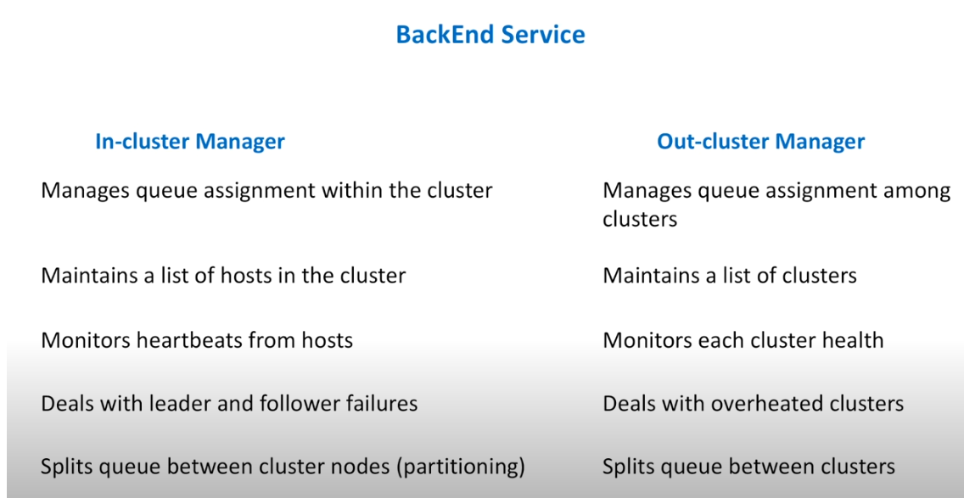

* Some other important features

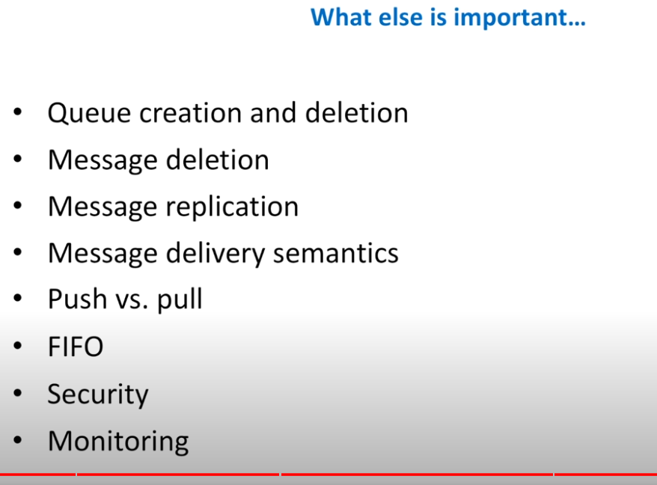

### Design Rate limiting

* Requirements
  + Functional
    - Implement server-side rate limiting
    - Block user based on IP, UserID etc
    - Send HTTP 429 status code on blocking
    - Logging mechanism for future use
  + Non-Functional
    - Scalable
    - Highly available
* Rate limiting is used to prevent DDOS attack, helps managing the load and cost [no need to add new servers]
* Rate limiting algorithms
  + Token bucket
    - Problem with this if load increases and bucket is empty then request cannot be processed.
  + Fixed window size
    - Problem if we have fixed window to solve 30 requests per 10 sec and all 30 request comes at 1 sec then in remaining 9 sec no request will be processed.
  + Sliding window
* High Level design of rate limiting for distributed env.

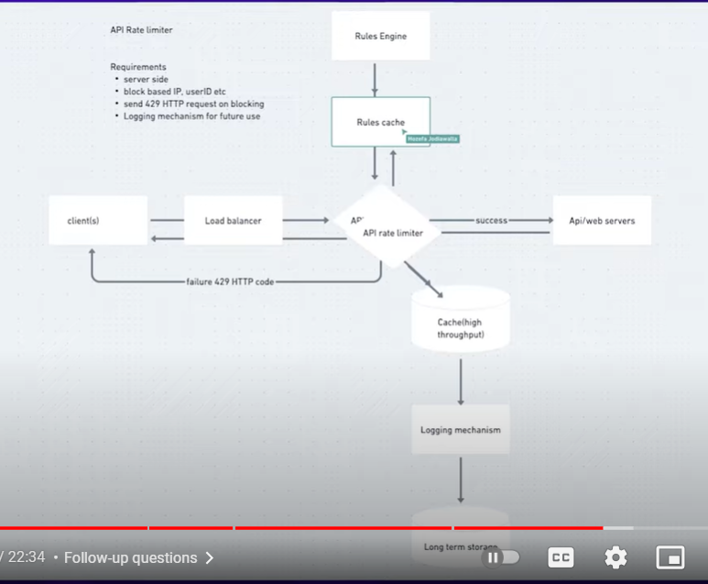

* Rate limiting should not be implemented per geographics, because user can mimic the different regions so if a user is blocked in India region, then it should block for all region.

### Auto Complete for search engine

* **Autocomplete**or **word completion**is a feature in which an application predicts the rest of a word a user is typing. In graphical user interfaces, users can typically press the tab key to accept a suggestion or the down arrow key to accept one of several. Autocomplete is involved in many search features on various platforms like Facebook, Instagram, Google search, etc.
* **Requirements**
  + Functional:
    - We need 7 autocomplete suggestions for each character we enter in the search box
    - It must be a real-time service. If a search query is trending, we must add it to our database, so that we can include it in our autocomplete suggestions.
  + Non-Functional:
    - Our system can expect 4 billion queries per day.
    - Low latency
    - Highly available
    - Eventual consistency
* System APIs
* get_suggestions(prefix)

prefix: Whatever the user has typed until the moment the search query is sent.

* add_to_db(query):

query: a new unique trending query which has been searched above a certain threshold will be stored in our DB.

* autocomplete consists of two parts:
  + Giving Suggestions
  + Adding new trending queries to the database
* When a user starts writing in the search box, the get_suggestions() query hits our application servers on every character the user enters. It obtains the top 7 suggestions from our DB and then serves it to the user. Let's keep a service called **Suggestions service**which is responsible to obtain the top 7 suggestions from the database.
* Along with this, if the query is popular, let's say the query has been searched above a certain threshold number, then it has to be added to the DB. Let's keep a service called **Trending Queries**service which is responsible to add the new trending queries to our database.

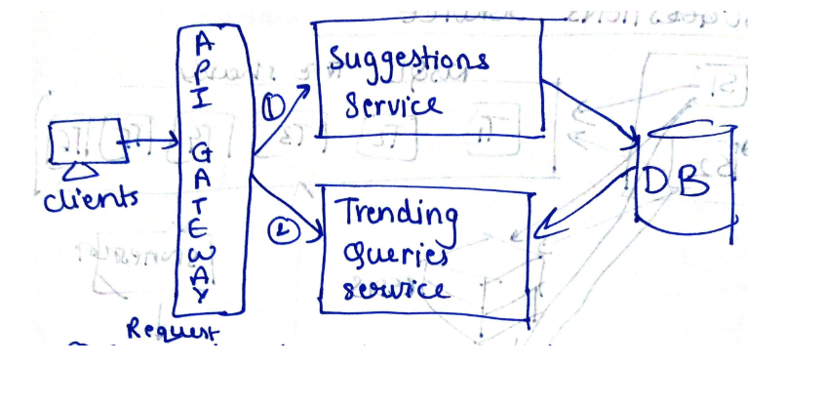

* Data structure to store search queries
* Trie is a data structure that fits the prefix search well. It gives search time complexity of O(l) where l is the length of the prefix which has been typed. It is also space-optimized.
* Basic trie

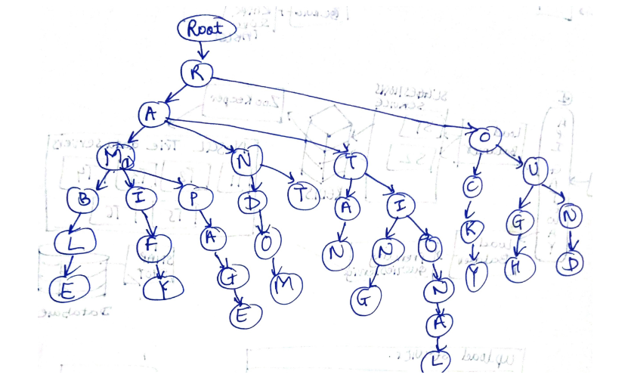

* In order to optimize space, we can merge nodes that have only one branch. Now trie will be stored like. Its called suffix tree

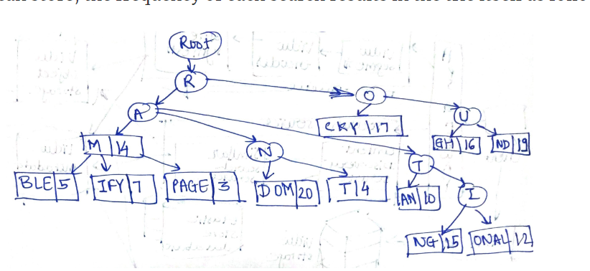

* Link : https://systemdesignprep.com/autocomplete

### Design Airbnb

* Requirements
  + Functional
    - Hotel
      * Onboard
      * Updates
      * Booking
    - User
      * Search
      * Book
      * Check bookings
    - Analytics
  + Non-Functional
    - Low Latency
    - High Availability
    - High Consistency
    - Scale
      * 500 K Hotels
      * 10 million Rooms in all hotels
      * 1000 rooms/hotel
* High Level design

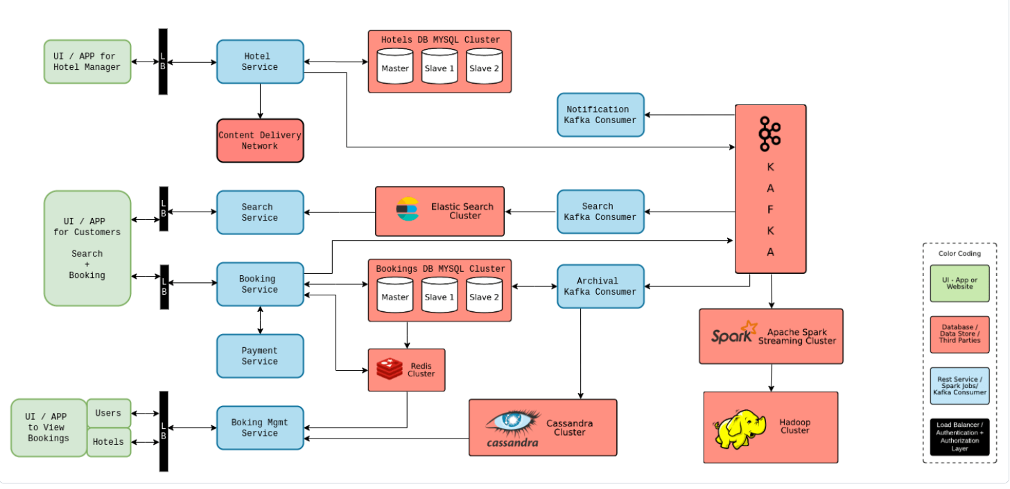

* API for hotel

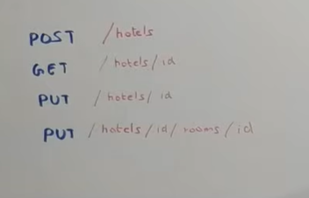

* Tables schema of SQL database in which hotel details are stored

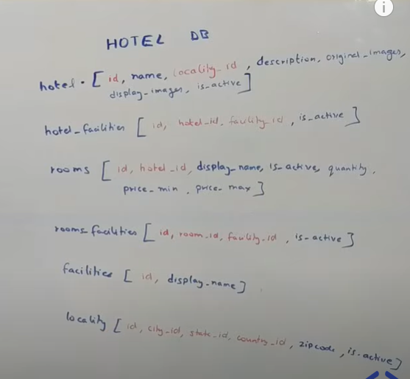

Here,

* + is_active column is used for deletion if hotel is deleted then is_active will have false value.
  + Red marked columns are primary and foreign keys
  + Blue marked columns are only columns.
* Booking DB schema

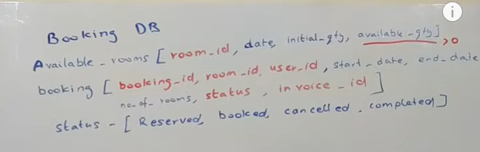

* Booking API

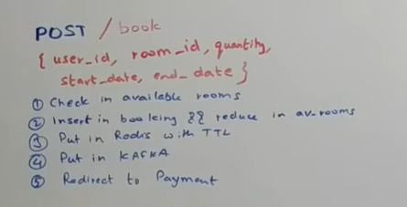

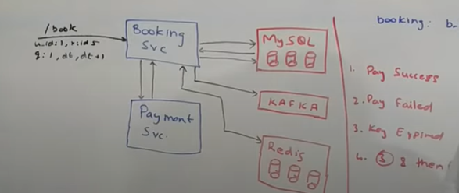

Here 4th point is key is expired and then payment is success.

* Topology

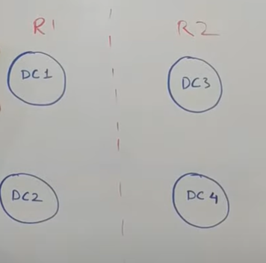

### Design Analytics Platform (Logging & Metrics)

* Requirements
  + Agnostic of platform
  + Data configurable
  + Visualization
* Non-Functional Requirements
  + Highly available
  + Low latency
  + Validation of data
* Payload of request sample

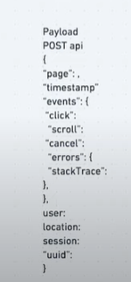

* High level design of Analytics system

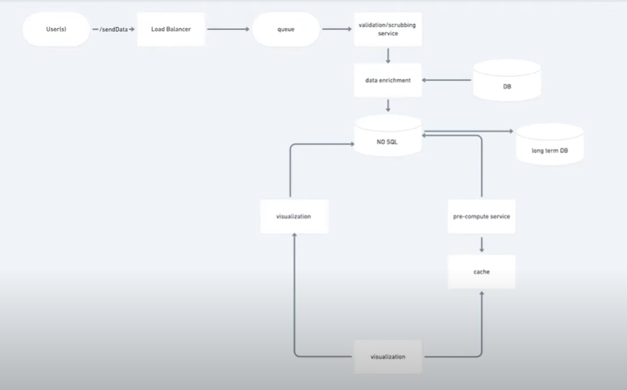

* No SQL is used as each event may have different data and it is not structured.

### Design Tiktok

* Requirements
  + Functional
    - Upload (Video + text)
    - View feed (video of followers, bonus recommendation)
    - Favourite videos + follow users
  + Non-Functional
    - High availability
    - Low latency
    - Scalable
* Estimates
  + Videos 5MB per video * 2 = 10 MB /day/user
  + User meta 1k per user per day
* High Level design

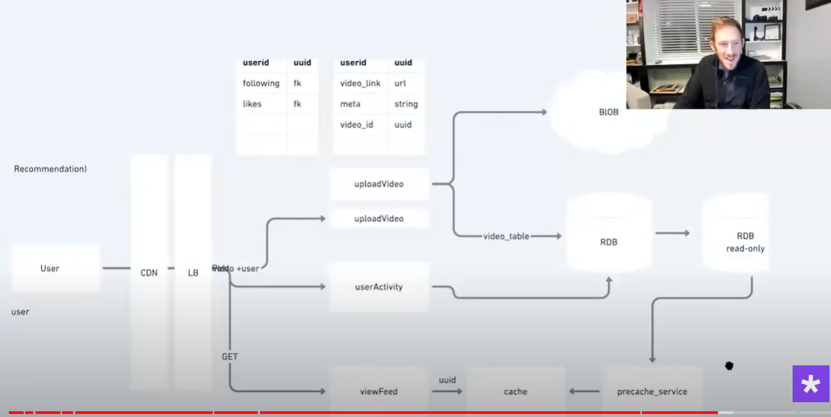

### Design Spotify

* Requirements
  + Functional
    - User can play songs
    - User can search songs
    - User can create playlist
    - App will have following
      * Songs
      * Users
      * Artists
      * Podcasts
      * Playlists
  + Non-Functional
    - Highly Available
    - Scalable
* Estimations

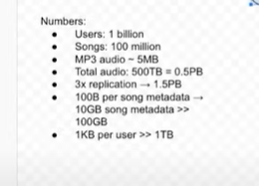

* High level design

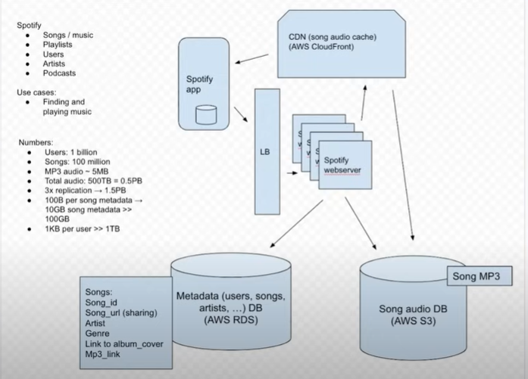

### Design Notification service

* **Requirements**
  + **Functional**
    - Send Notifications
    - Plugable and extendable - easy enough to add to any application and easy to extend to different kinds of notification
    - SaaS - We might need to impose rate-limit - It could be to avoid spamming a user with promotional messages or to ensure external systems are not exerting too much load on any of the services.
    - Prioritization - certain messages like OTP are higher priority, whereas promotional messages are lower priority
  + **Non-Functional**
    - Always available
    - Easy enough to add more clients
    - Scalable: Should be linearly scalable if we want to expose this as a SaaS Notification service to variou companies of Amazon/Twitter scale.
* High Level design

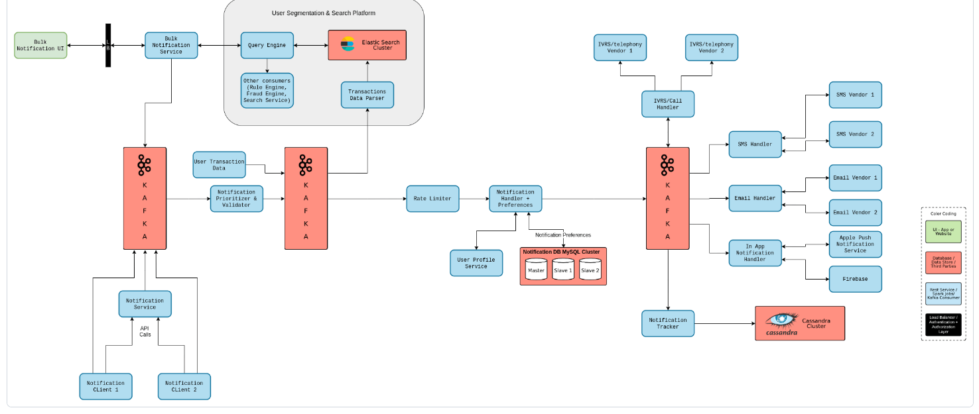

* For theory: https://www.codekarle.com/system-design/Notification-system-design.html

## Learning from HLD questions

* For storing images, video, and audio, following can be used:
  + Database that supports BLOB storage
  + S3 blob storage
  + Distributed file system
* For direct message (one to one or group message) apps, WebSocket with persistent connection will be used.
* API gateway can do routing of request to load balancer and load balancer will send the response back to API gateway and on the basis of response API gateway can re-route the request to next service.
  + Ex. API gateway route the incoming request to profile service first. After getting response from profile service, API gateway reroute request to other service.
* For streaming videos, system uses CDN.
* For recommendations, AI/ML (Apache spark) is used on user activity data.
* DNS is load balancer and CDN is cache.
* For searching in google, NLP is used in which inverted index is created.

## Summary notes of HLD

* **System Building Blocks**
  + User Interface
  + Load Balancer or API Gateway
  + Application / Backend services
    - Main task – Do Synchronous
    - Additional task – Do Asynchronously
    - At most 1 service can read or write from the database. [DO NOT VIOLATE THIS]
  + Databases
    - Factors on which database decision depends on
      * Structure of the data
      * Query pattern
      * Amount or scale that you need to handle
    - SQL
      * Relation in data
      * Structured data i.e. fixed set of properties.
      * Transaction support / ACID properties
    - Cassandra
      * if you have a huge scale of queries but less variety in queries, and most of your queries are such that you can include a common partition key in the where clause for each of the queries, then Cassandra works beautifully!
    - Elasticsearch
    - Hadoop/Spark
    - Redis

**Note**:

If we have structured data and need acid properties use Relational database like MySQL if we have huge data with a lot of attributes, we can use a document DB like Mongo DB, If we have a simpler data with less variety of queries, we use columnar databases like Cassandra.

**Links:**

<https://www.codekarle.com/system-design/Database-system-design.html>

<https://aws.amazon.com/compare/the-difference-between-cassandra-and-mongodb/#:~:text=Cassandra%20is%20an%20early%20NoSQL,fast%20read%20and%20write%20performance>.

Columnar vs Row-wise db:<https://www.tinybird.co/blog-posts/what-is-a-columnar-database>

Key-value:

Wide-column:

<https://www.quora.com/Is-DynamoDB-a-columnar-database>

<https://www.tinybird.co/blog-posts/what-is-a-columnar-database>

|  |  |  |  |
| --- | --- | --- | --- |
| **Type of Database** | **AWS Service Name** | **Open-Source Database** | **Use Cases** |
| Relational | Amazon RDS | MySQL, PostgreSQL, MariaDB, Oracle, SQL Server | Traditional applications, ERP, CRM, web applications, e-commerce platforms |
| Relational | Amazon Aurora | MySQL, PostgreSQL | High-performance transactional applications, SaaS applications |
| Relational | Amazon Redshift | - | Data warehousing, business intelligence, analytics |
| NoSQL (Key-Value) | Amazon DynamoDB | - | Real-time bidding, gaming, IoT, session management, mobile applications |
| Document | Amazon DocumentDB | MongoDB | Content management, catalogs, user profiles, mobile applications |
| In-Memory | Amazon ElastiCache | Redis, Memcached | Caching, real-time analytics, session stores, gaming leaderboards |
| Graph | Amazon Neptune | - | Social networking, recommendation engines, fraud detection, knowledge graphs |
| Time Series | Amazon Timestream | - | IoT applications, operational analytics, event tracking, application monitoring |
| Ledger | Amazon QLDB | - | Financial transactions, supply chain, inventory management, registrations |
| Search | Amazon OpenSearch Service | OpenSearch, Elasticsearch | Log analytics, full-text search, monitoring, security information and event management (SIEM) |
| Data Lake | Amazon S3 (with AWS Glue, Amazon Athena, etc.) | - | Big data analytics, data archiving, machine learning, data lakes |

1. Social Media
   1. Instagram
   2. Tinder
   3. Facebook
   4. Twitter
   5. Reddit
   6. TikTok
   * Common Functionality:
     + Store Images or Videos
     + Generate feed
     + Recommendation
     + View friends’ profile
     + Post Images or Videos
2. Chat applications
   1. WhatsApp
   * Common Functionality:
     + Send messages, Images or Videos
     + WebSocket connection will be maintained
3. E commerce
   1. Amazon
   2. Shopify
   * Common Functionality:
     + Inventory
     + Payment
     + Order Place
     + Recommendation
     + Track order
4. Streaming apps (Music/Video)
   1. Netflix
   2. YouTube
   3. Spotify
   * Common Functionality:
     + Fast streaming
     + Upload videos/songs
     + Search
     + Recommendation
5. Booking Systems
   1. Airbnb
   2. Flight Booking
   3. Uber
   * Common Functionality:
     + Schedule or book ticket
     + Search
     + Payment
     + Recommendation
6. Distributed system building blocks
   1. CDN
   2. Distributed key value store
   3. Cache
   4. Job Scheduler
   5. Authentication system
   6. Rate Limiter
   7. Kafka
   * Common Functionality:
     + Understand working of Distributed system building blocks like how cache works, Kafka works
     + Design the system accordingly
7. Other systems
   1. Tiny URL shortener
   2. Pastebin
   3. Parking Garage
   4. Vending Machine
   5. UPI
   6. Google search
   7. Auto Search
   8. Code Editor
   9. Stock Exchange
   10. Analytics Platform
   11. Payment System
   12. Notification service
   * Common Functionality:
     + Understand working of system then list service and their interactions
     + Design the system accordingly